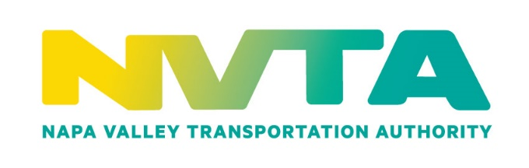

Napa Valley Transportation Authority

625 Burnell Street

Napa, CA 94559

Tel. (707) 259-863 / Fax (707) 259-8638

www.nvta.ca.gov

COMMITTEE APPOINTMENT APPLICATION

Complete applications can be submitted by: (1) faxing to the Human Resources Administrator at (707) 259-8638 or (2) delivered/mailed to the NVTA Attention: Human Resources Administrator, 625 Burnell Street, Napa, CA 94559 or (3) Email to: jobs@nvta.ca.gov.

This application may be subject to disclosure under the Public Records Act

Applicant Information
Application for Appointment to: (Name of Committee) Citizens Advisory Committee (CAC)
Representing Field of_____________________________________________________________________________
Name: |  |  |  |  |  |  | Date:
Last |  |  | First |  |  | M.I.
Address:
Street Address |  |  |  |  |  | Apartment/Unit #
City |  |  |  |  |  | State |  | Zip
Phone: |  |  |  | E-mail Address:

Current Occupation (within the last twelve (12) months)

Current License (Professional or Occupational): Date of Issue and/or expiration including status:

Education/Experience

(a resume may be attached containing this and any other information that would be helpful in evaluating your application)

Community Participation

(nature of activity and community location)

Other Board/Commission/Committee on which you serve/have served

References
Please list three individuals familiar with your background
Full Name: |  | Relationship:
Company: |  |  |  | Phone:
Address:
Full Name: |  | Relationship:
Company: |  |  | Phone:
Address:
Full Name: |  | Relationship:
Company: |  |  |  | Phone:
Address:

Name and Occupation of spouse within the last 12 months, if married (for Conflict of Interest purposes):
Please explain your reasons for wishing to serve, and in your opinion, how you feel you could contribute.

Disclaimer and Signature
PLEASE NOTE THAT APPOINTEES MAY BE REQUIRED BY STATE LAW AND NVTACONFLICT OF INTEREST CODE TO FILE FINANCIAL DISCLOSURE STATEMETS

Signature: |  |  |  |  | Date:

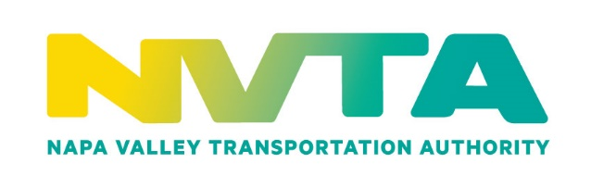

EQUAL EMPLOYMENT OPPORTUNITY DATA

The Napa Valley Transportation Authority is an equal opportunity employer. In accordance with the applicable laws and regulations, the agency does not discriminate on the basis of disability or other prohibited criteria. The information requested below is for statistical reporting and analysis as required by law only. We request that all applicants complete the following information, however providing this information is voluntary. This information will be detached from your application and the information will be kept confidential.

Name ________________________________________________________ Date _________________

Position Applied For ___________________________________________________________________

Sex: ___ Male ___Female Disabled: ___ Yes ___ No

Race/Ethnicity: (Check only one.)

___ AMERICAN INDIAN/ALASKAN NATIVE
All persons having origins in any of the original peoples of North America, and who maintain cultural identification through tribal affiliation or community recognition.

___ BLACK
Not of Hispanic origin; All persons having origins in any of the Black racial groups of Africa.

___ WHITE
Not of Hispanic origin; All persons having origins in any of the original peoples of Europe, North Africa, or the Middle East.

___ HISPANIC
All persons of Mexican, Puerto Rican, Cuban, Central or South American or other Spanish culture or origin, regardless of race.

___ ASIAN/PACIFIC ISLANDER
All persons having origins in any of the original peoples of the Far East, Southeast Asia, the Indian Subcontinent, or the Pacific Islands, such as China, Japan, Korea, Vietnam, and Samoa.
- Two or More Races (Non-Hispanic or Latino) - Persons who identify with two or more racial categories named above.
- Decline to State - If you choose not to self-identify your race/ethnicity at this time, the federal government requires this employer to determine this information by visual survey and/or other available information.

To assist NVTA in our recruitment efforts, please indicate how you found out about the job.

___ Newspaper (specify) ___________________________________________________________________

___ Other Publication (specify) ______________________________________________________________

___ Friend

___ School or other placement office (specify) __________________________________________________

___ NVTA Employee / Website

___ Other (specify) _______________________________________________________________________

___ Walk-in

